**MAX 526 / MSC 651**

**Quantitative Models for Marketing**

**Dr. Dinakar Jayarajan**

**Assignment 1**

**Question 1: Convert the data file SVEDKA.csv to a SAS dataset.**

The following code was implemented to answer the question:

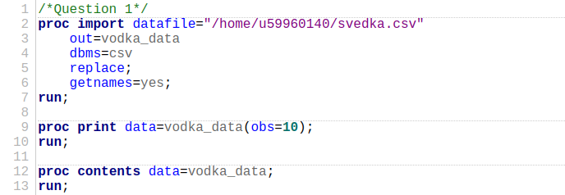

The following output was produced:

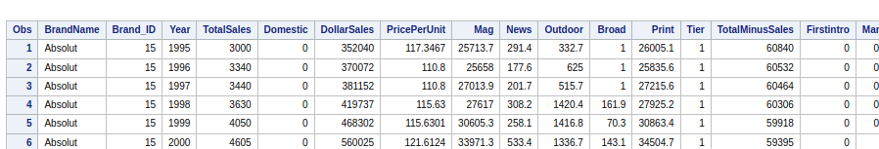

The dataset contains 263 observations and 17 variables on vodka sales including advertising expenditures, market share, and other characteristics. Variables such as TotalSales, DollarSales, and Marketshare quantify financial performance. On the other hand, PricePerUnit and Domestic indicate product pricing and local origin. Advertising metrics include Mag, News, Outdoor, Broad, and Print capture spending on various media channels. BrandName and Brand_ID identify the different vodka brands. The data spans many years.

**Question 2: Summary statistics for the data**

The following code was implemented to answer the question:

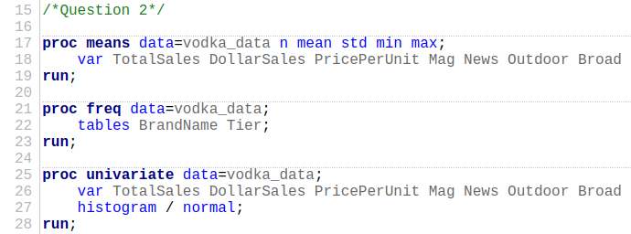

The code produced the following output:

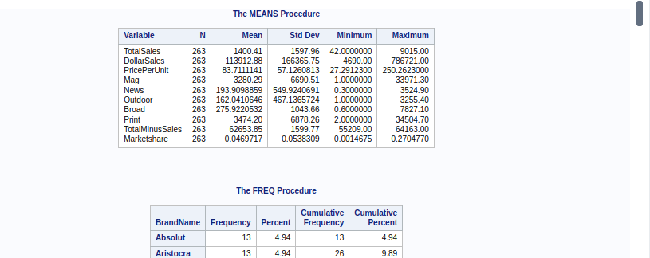

The dataset shows a lot of variability and non-normality in several variables. For example, the total sales data, with a mean of $1400.41 and a standard deviation of $1597.96. This is a good example of skewness and kurtosis meaning a heavy-tailed distribution. Dollar sales also demonstrate high variability, with a mean of $113,912.88 and a coefficient of variation of 146.05%. This is a strong deviation from normality. Other variables, such as Mag, News, Outdoor, and Broad show pronounced skewness and kurtosis which is a non-normal distribution.

**Question 3**

The following code implemented to answer the question:

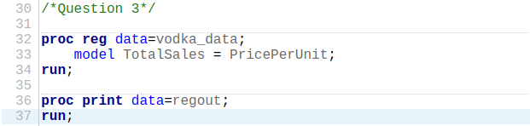

The code produced the following output:

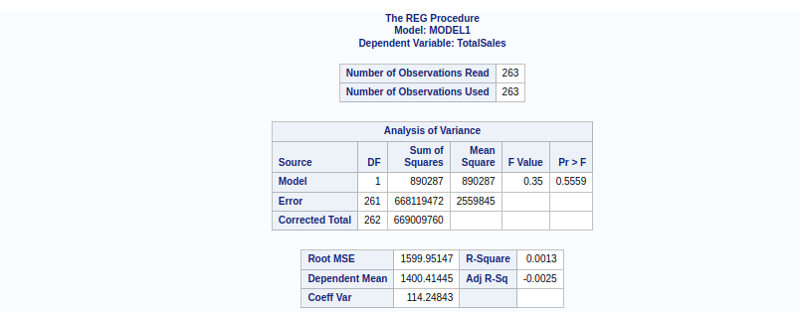

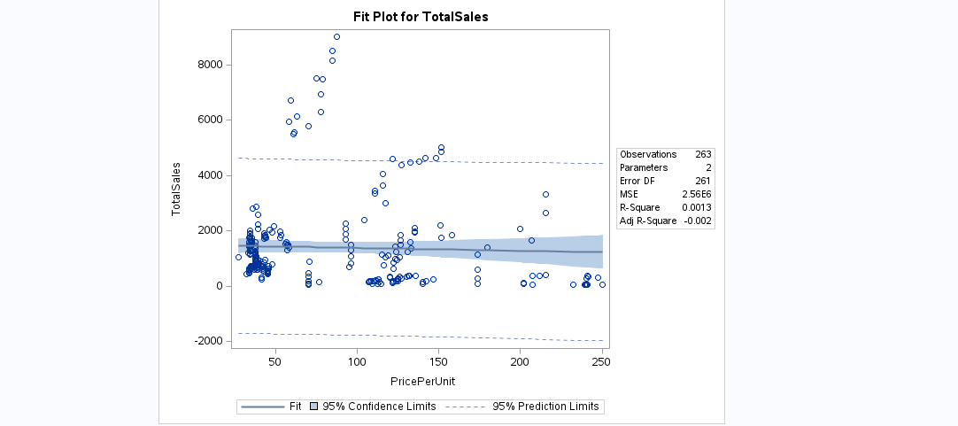

**Equation: $TotalSales=1485.83515−1.02042×PricePerUnit$**

The intercept of 1485.83515 shows that the estimated total sales when the price per unit is zero, this value is not realistic. The coefficient for PricePerUnit is -1.02042, indicating that each unit increase in price is expected to decrease total sales by approximately 1.02042 units. However, with a p-value of 0.5559 for this coefficient, higher than the 0.05 threshold, the relationship between PricePerUnit and TotalSales is assumed to be not statistically significant. The R-Squared value of 0.0013 shows that the model accounts for only a small fraction of the variability in total sales. Therefore, price per unit does not have a meaningful impact on total sales in this dataset.

**Question 4: Run a regression which includes price and advertising.**

The following code implemented to answer the question:

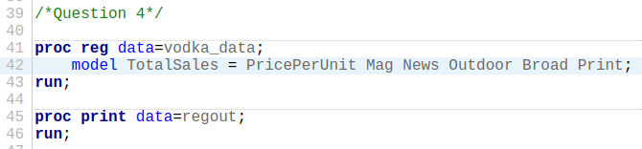

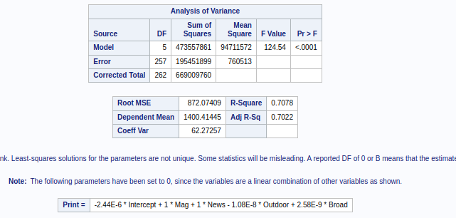

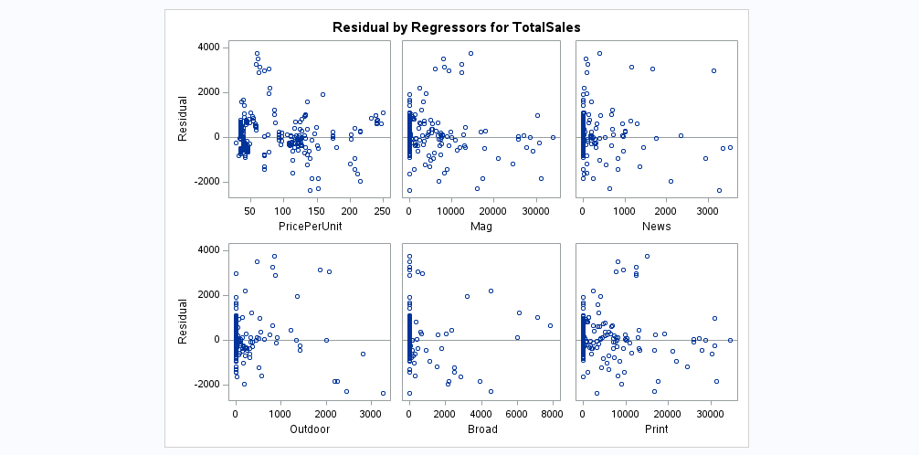

In the dataset, the variables representing advertising include Mag, News, Outdoor: Outdoor, Broad, and Print. To specify the model, I included both price and all available advertising variables as predictors for TotalSales. This was necessary to assess the combined impact of advertising and pricing on sales. Since Print was found to be a linear combination of other variables and had no unique contribution, it was set to zero in the model.

The regression equation is: $TotalSales=1582.55091−10.47726×PricePerUnit+0.09654$

$×Mag+0.12754×News+0.61292×Outdoor+0.92121×Broad$

The intercept value of 1582.55091 shows the estimated total sales when all predictors are zero. The coefficient of -10.47726 for PricePerUnit shows that for each unit increase in price, total sales are expected to decrease by approximately 10.48 units. A highly significant relationship with a p-value of <.0001.

**Question 5: Dummy variables for the Tier variable**

The following code was implemented to answer the question:

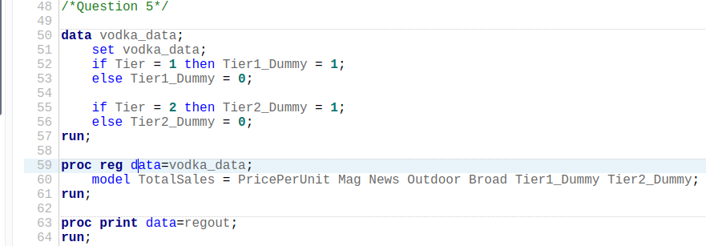

The code produced the following output:

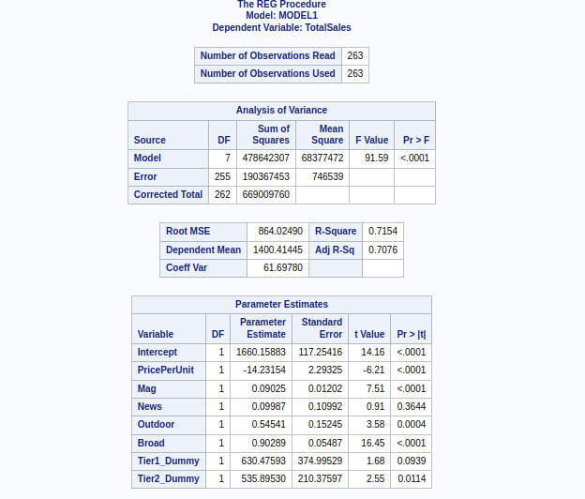

Since the dataset classifies brands into three quality tiers, we need 2 dummy variables. The dependent variable is TotalSales, and the independent variables include PricePerUnit, advertising variables Mag, News, Outdoor, Broad, and dummy variables for the product tiers, Tier1_Dummy and Tier2_Dummy.

**Question 6: Including Tier dummies to the model**

The following model was implemented to answer the question:

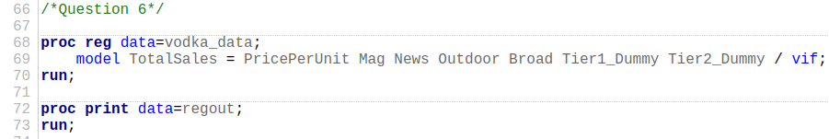

Output:

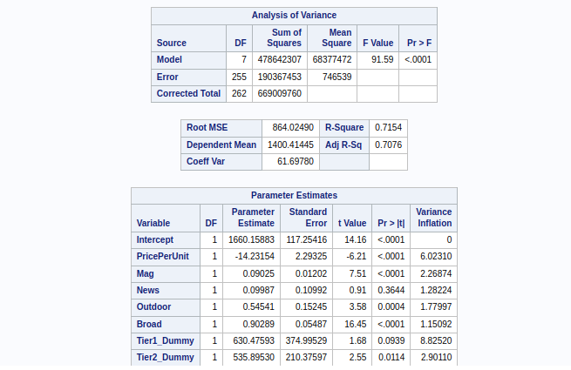

The regression results show that the Tier 1 dummy has a positive coefficient, 630.47593 but is not statistically significant at the 0.05 level, p-value = 0.0939, while the Tier 2 dummy has a positive and statistically significant effect, 535.89530, p-value = 0.0114. This means that Tier 2 brands, such as Svedka boost total sales compared to Tier 3 brands. While Tier 1 brands have higher total sales, the lack of statistical significance shows that their advantage is not enough to warrant Svedka’s immediate entry into Tier 1. Competing in Tier 1 could be risky.

**Question 7: Compute the demand elasticity of price**

The following code implemented to answer the question:

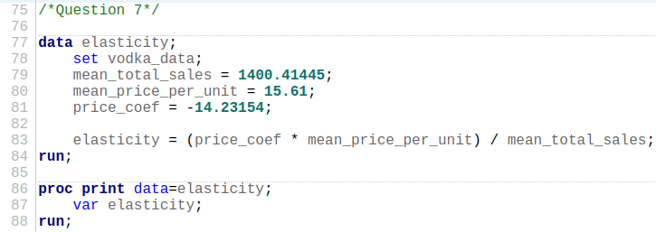

The code produced the following output:



The computed price elasticity of demand is − 0.15863, which indicates that vodka prices are inelastic. This means that a 1% increase in the price of vodka is associated with a 0.15863% decrease in the quantity demanded. This simply means that the demand for vodka is not very sensitive to changes in price. Therefore, Svedka can consider increasing prices without expecting a proportionally large drop in sales volume. However, while the price increase might not significantly impact sales volume, it is important for Svedka to assess the potential impact on customer perception and competition before making pricing decisions.

**Question 8: Recommendations**

Given that the price elasticity of demand is −0.15863-0.15863−0.15863 which shows inelastic demand, Svedka has some leeway to increase prices without impacting sales volume very much. However, they should weigh this against potential customer perception and competitive dynamics. The regression results suggest that advertising expenditures positively influence sales, so Svedka should continue investing in advertising channels like Mag, News, Outdoor, and Broad to drive higher sales. Although Tier 2 brands are significantly associated with higher sales compared to Tier 3, Tier 1 brands, despite their higher sales, are not statistically significant, meaning that immediate entry into Tier 1 may not work out well. Therefore, Svedka should focus on maintaining its position in Tier 2, optimizing advertising strategies, and cautiously considering price adjustments to maximize profitability while managing market risks.

**Appendix**

| /*Question 1*/  proc import datafile="/home/u59960140/svedka.csv"  out=vodka_data  dbms=csv  replace;  getnames=yes;  run;  proc print data=vodka_data(obs=10);  run;  proc contents data=vodka_data;  run;  /*Question 2*/  proc means data=vodka_data n mean std min max;  var TotalSales DollarSales PricePerUnit Mag News Outdoor Broad Print TotalMinusSales Marketshare;  run;  proc freq data=vodka_data;  tables BrandName Tier;  run;  proc univariate data=vodka_data;  var TotalSales DollarSales PricePerUnit Mag News Outdoor Broad Print TotalMinusSales Marketshare;  histogram / normal;  run;  /*Question 3*/  proc reg data=vodka_data;  model TotalSales = PricePerUnit;  run;  proc print data=regout;  run;  /*Question 4*/  proc reg data=vodka_data;  model TotalSales = PricePerUnit Mag News Outdoor Broad Print;  run;  proc print data=regout;  run;  /*Question 5*/  data vodka_data;  set vodka_data;  if Tier = 1 then Tier1_Dummy = 1;  else Tier1_Dummy = 0;  if Tier = 2 then Tier2_Dummy = 1;  else Tier2_Dummy = 0;  run;  proc reg data=vodka_data;  model TotalSales = PricePerUnit Mag News Outdoor Broad Tier1_Dummy Tier2_Dummy;  run;  proc print data=regout;  run;  /*Question 6*/  proc reg data=vodka_data;  model TotalSales = PricePerUnit Mag News Outdoor Broad Tier1_Dummy Tier2_Dummy / vif;  run;  proc print data=regout;  run;  /*Question 7*/  data elasticity;  set vodka_data;  mean_total_sales = 1400.41445;  mean_price_per_unit = 15.61;  price_coef = -14.23154;  elasticity = (price_coef * mean_price_per_unit) / mean_total_sales;  run;  proc print data=elasticity;  var elasticity;  run; |
| --- |